LAB SHEET


K.R. MANGALAM UNIVERSITY SOET
(School of Engineering & Technology)
B. TECH CSE (CORE)
Database & Management System Lab (ENCS254)

Submitted by- Submitted to-
Jony Gautam Mansi Kajal
Roll no - 2401010032

LAB SHEET - 1

Objective: To design ER diagrams and convert entities and relationships into relational tables using proper schema notation.

DDL Commands
  - Create Database
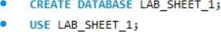

PART A – COLLEGE DATABASE
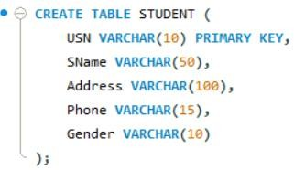
  - Create Tables with Primary and Foreign Keys
  - Create SEMSEC Table
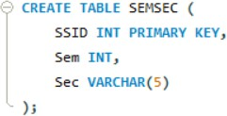
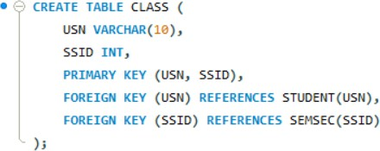
  - Create CLASS Table
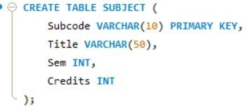
  - Create SUBJECT Table
  - Create IAMARKS Table
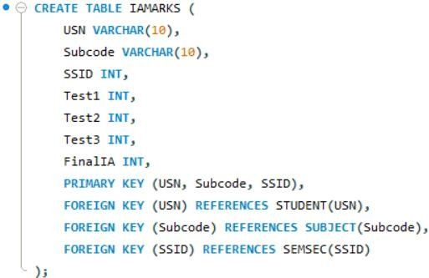

PART B – COMPANY DATABASE
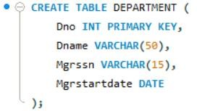
- Create DEPARTMENT Table
- Create EMPLOYEE Table
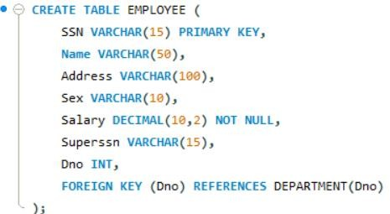
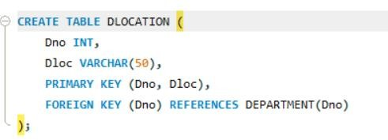
- Create DLocation Table

- Create PROJECT Table
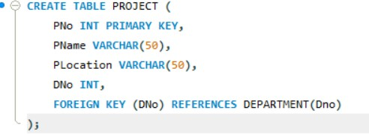

- Create WORKS_ON Table
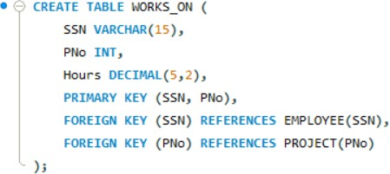

PART C – CUSTOMER SALE DATABASE
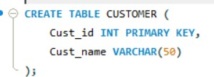
- Create CUSTOMER Table
- Create ITEM Table
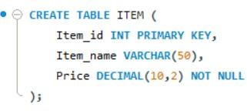

- Create SALE Table
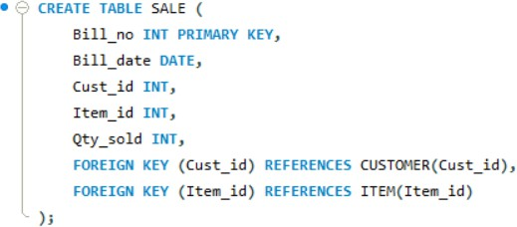

  - ALTER OPERATIONS
- Add Email Column
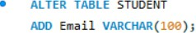

- Rename SName to StudentName
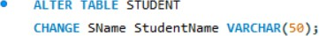

- Drop DLOCATION Table

DML Commands
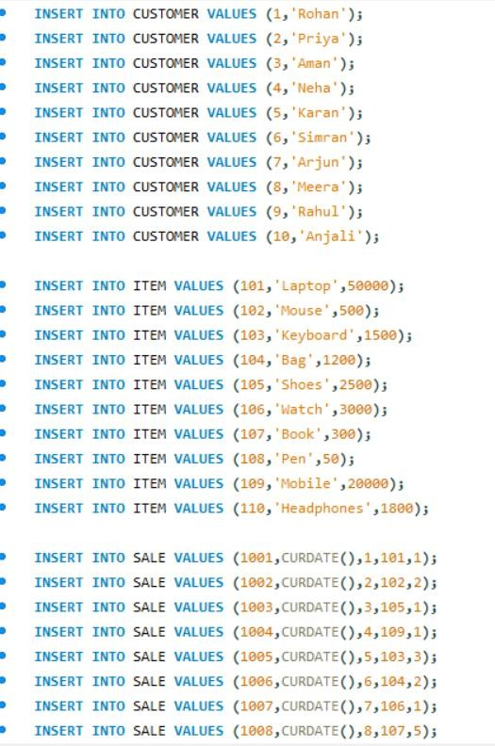
- Inserted 10 records into CUSTOMER, ITEM and SALE tables.

- Bills of Current Date:
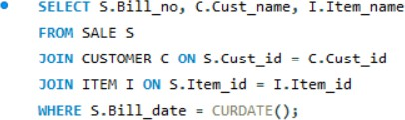

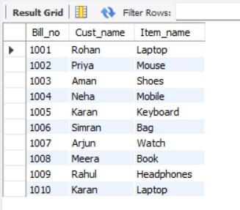
Output:
- Total Bill Amount:
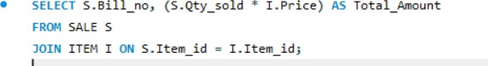
Output:
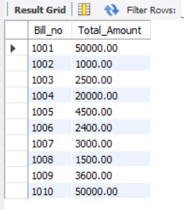
- Customers who purchased products priced above 200.
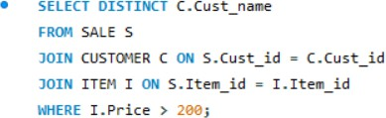

Output:
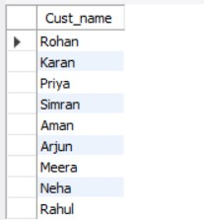
- Count number of products purchased by each customer.
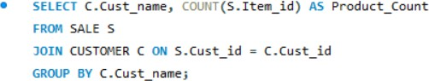

Output:
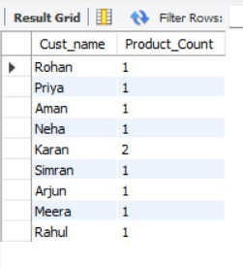
- Products purchased by customer with Cust_id = 5.
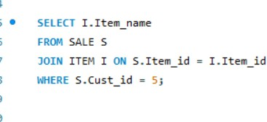

Output:
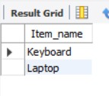
  - Views Created
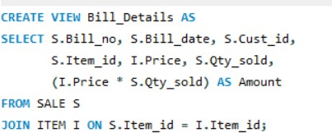
- Bill_Details View (shows bill_no, bill_date, cust_id, item_id, price, qty_sold, amount).

Output:
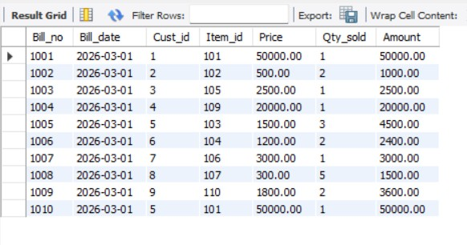
- Weekly_Sales View (shows daily total sales for last one week).
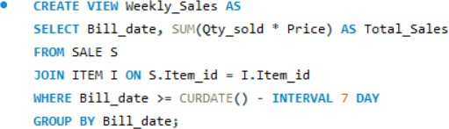

Output:
